COMSOL OY  Arabiankatu 12  00560 Helsinki, Finland  Tel: +358 9 2510 400  Web: www.comsol.fi  E-mail: info@comsol.fi | Media Contact:  Jukka Tarvo  jukka@comsol.com  COMSOL News 2018 is available at:  www.comsol.fi/offers/comsol-news-2018

Multiphysics Modeling and Simulation Apps
Inform Better Business and Engineering Solutions

HELSINKI, FINLAND (May 7, 2018) — COMSOL, Inc. published the annual edition of COMSOL News today. The magazine features case studies of simulation specialists working with their colleagues and customers to find solutions that can satisfy both business and engineering goals. Enabled by high-fidelity multiphysics models of the products they want to design and a culture of collaboration with the convenience of simulation apps, engineers are pushing the limits of technology while reducing the need for physical prototypes. COMSOL News 2018 reports on how creating accurate digital prototypes and deploying simulation apps has become standard practice among industry leaders.
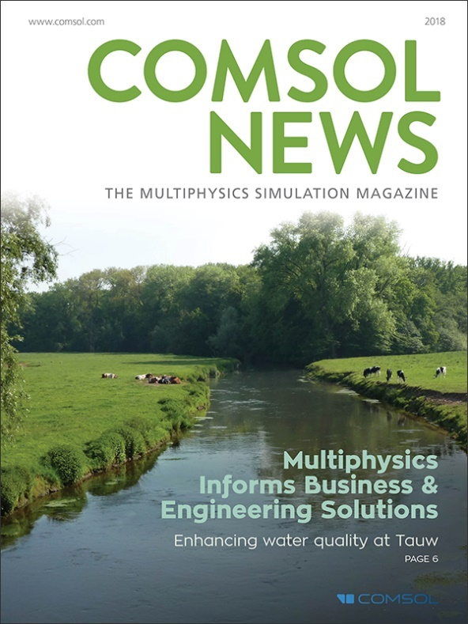
Justin McKennon, who leads the Modeling and Analytical Team at NTS Pittsfield, said “Time is money in our industry, and our customers are very pleased with the service we’re able to provide thanks to our multiphysics modeling capabilities. In fact, some customers are so confident in the validity of our simulations that they’ve begun to make wholesale business decisions based solely on our results.” NTS is a world leader in the design and validation of sophisticated lightning protection systems for the aerospace industry, including aircraft, space vehicles, and launch facilities.

COMSOL News 2018 features more than a dozen articles covering a diverse range of projects making use of multiphysics modeling and apps distributed through organizations’ internal portals. Featured articles discuss: biopharmaceutical processes, minimizing corrosion in multimaterial assemblies, gear lubrication, automotive product design, semiconductor manufacturing breakthroughs, enhancing water quality, and developing noncontact magnetic couplings.

“Numerical simulation impacts every aspect of the world around us. Keeping the environment clean is one important example. Our cover features the Dommel river in The Netherlands, which is thriving thanks to the engineers at Tauw and their simulation work,” says Valerio Marra, marketing director, COMSOL, Inc. “The simulation specialists featured in this year’s edition of COMSOL News are making the world a better place. They don’t do it alone though, engineers across departments and continents are working together to solve the challenges that remain in building better products and processes.”

Availability
COMSOL News 2018 is available as an online magazine and can be viewed digitally or downloaded in PDF format at: www.comsol.fi/offers/comsol-news-2018.

About COMSOL
COMSOL is a global provider of simulation software for product design and research to technical enterprises, research labs, and universities. Its COMSOL Multiphysics® product is an integrated software environment for creating physics-based models and simulation apps. A particular strength is its ability to account for coupled or multiphysics phenomena. Add-on products expand the simulation platform for electromagnetics, structural, acoustics, fluid flow, heat transfer, and chemical applications. Interfacing tools enable the integration of COMSOL Multiphysics® simulations with all major technical computing and CAD tools on the CAE market. Simulation experts rely on the COMSOL Server™ product to deploy apps to their design teams, manufacturing departments, test laboratories, and customers throughout the world. Founded in 1986, COMSOL employs more than 450 people in 19 offices worldwide and extends its reach with a network of distributors.
~
COMSOL, COMSOL Multiphysics, LiveLink, and COMSOL Server are either registered trademarks or trademarks of COMSOL AB. For other trademark ownership, see www.comsol.com/trademarks.

